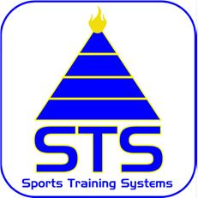
STS NUTRITION
“Optimal health made easy”
www.sts.co.nz

Oatcakes
Ingredients
150g medium oatmeal
1 tsp unsalted butter (or dairy free alternative)
125 ml/4 fl oz boiling water
Wheat free flour for rolling mixture out onto
Method
Preheat oven to 350F/180C/Gas 4
Put oatmeal into a bowl
Put butter into a heatproof jug and pour boiling water onto it
When the butter has melted, pour the liquid over the oats and mix well
Leave for a few minutes till oatmeal swells and becomes workable
Turn onto a well floured board (using the wheat free flour)
Divide into balls
Roll each ball out thinly and use a pastry cutter or the top of a small glass to cut into rounds
Place on a baking sheet in the oven for about 30 minutes until light golden
(White E “Beat Candida Cookbook”)
Georgina Marshall DipION

